Cointegration and ECM: GBPUSD and USDJPY
Method 27 / Engle-Granger on log closes / one-lag ECM / Alpari D1 full available history

Study setup
Logical pair: PX=GBPUSD , PY=USDJPY
Broker symbols: GBPUSD_i , USDJPY_i
Snapshot: 2026-11-03_majors_alpari_D1
Timeframe: D1
Matched window: 1999-01-05 to 2026-11-02 (UTC bar dates)
Matched level count n: 7200
Dropped unfinished last bar dated 2026-11-03 UTC after a tick-volume check against the prior complete day.
ECM lags of deltas: 1
Complete matched rows (Excel): GBPUSD-USDJPY_Coint_D1.xlsx
Complete matched rows (HTML table): GBPUSD-USDJPY_Coint_D1_data.html

Method carried forward
Engle-Granger cointegration works on log price levels, not returns. For each unordered pair, PX is the left leg and PY the right leg. Step one: OLS ln(PY) = alpha + beta * ln(PX) + e. Step two: statsmodels Engle-Granger coint test on (ln(PY), ln(PX)). Error-correction: delta ln(PY)_t = c + kappa * e_{t-1} + lagged delta ln(PY) and delta ln(PX) (one lag each) + u_t. Headline is the Engle-Granger p-value (lower = stronger evidence of a stationary spread) with kappa and beta reported alongside. Same-sample Pearson r of log returns is a side check only. beta is not an automatic lot-size hedge. This is not a trading signal.

Results (headline)
alpha: 4.906447
beta: -0.457698
Engle-Granger t: -1.174341
Engle-Granger p: 0.864492
5% critical value: -3.336979
ECM kappa: -0.000592
kappa t-stat: -1.2535
ECM R^2: 0.001321
spread std: 0.154899
Pearson r (returns): -0.198556

Conclusion
Engle-Granger for PY=USDJPY on PX=GBPUSD: beta=-0.4577, alpha=4.9064, coint_t=-1.1743, p=0.8645 (5% crit=-3.3370). ECM kappa=-0.0006 (t=-1.25). Pearson r of returns = -0.1986. beta is not a lot-size hedge. Not a trading signal.

Charts
Daily closes

Engle-Granger residual spread
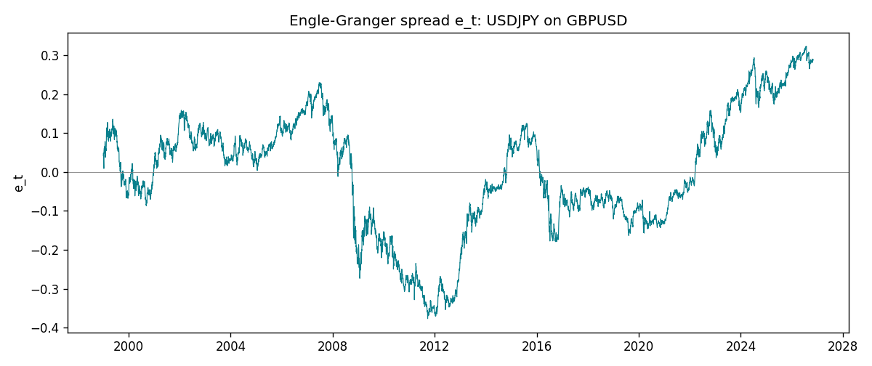
Daily log returns
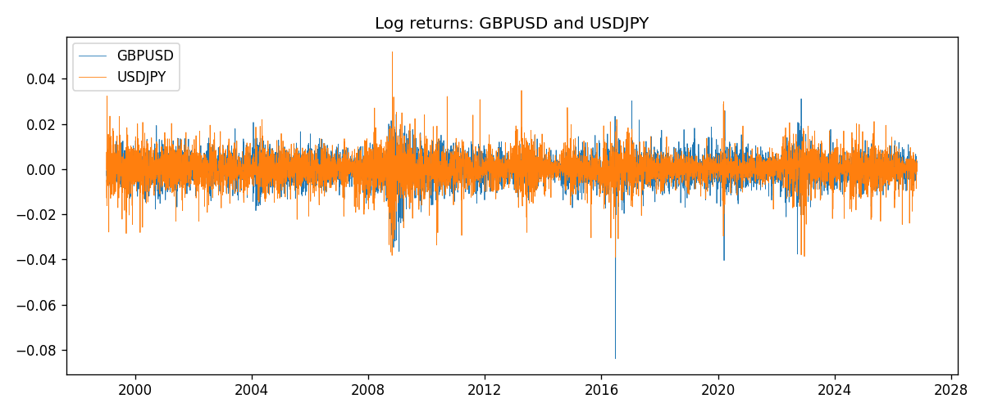

Data report
Matched rows are in the sibling Excel workbook named GBPUSD-USDJPY_Coint_D1.xlsx. Embedding all rows as a Word table is impractical; this file holds column summaries and the first and last 15 matched rows.
Column summaries
column | count | mean | std | min | 25% | 50% | 75% | max
GBPUSD_open | 7200 | 1.5159933 | 0.21821503 | 1.06854 | 1.3249725 | 1.51133 | 1.63163 | 2.1066
USDJPY_open | 7200 | 113.81122 | 19.205564 | 75.693 | 104.42925 | 110.991 | 120.69125 | 163.824
GBPUSD_high | 7200 | 1.5222906 | 0.21878569 | 1.08366 | 1.329785 | 1.518035 | 1.638315 | 2.1161
USDJPY_high | 7200 | 114.30876 | 19.267108 | 76.001 | 104.8815 | 111.4435 | 121.26 | 163.978
GBPUSD_low | 7200 | 1.5096683 | 0.2174426 | 1.03518 | 1.319445 | 1.50319 | 1.6243 | 2.0983
USDJPY_low | 7200 | 113.28793 | 19.133561 | 75.402 | 103.89 | 110.5305 | 120.17 | 163.628
GBPUSD_close | 7200 | 1.5160611 | 0.21817876 | 1.06879 | 1.3250775 | 1.511235 | 1.63193 | 2.1065
USDJPY_close | 7200 | 113.82409 | 19.220954 | 75.811 | 104.42 | 111.028 | 120.6855 | 163.851
GBPUSD_tick_volume | 7200 | 94838.03 | 153554.65 | 62 | 10001.75 | 52905.5 | 91812.25 | 1273370
USDJPY_tick_volume | 7200 | 106136.9 | 179308.31 | 149 | 9925 | 53095 | 92761 | 1803508
GBPUSD_spread | 7200 | 26.967917 | 19.192953 | 0 | 11 | 20 | 50 | 50
USDJPY_spread | 7200 | 20.325556 | 17.633971 | 0 | 6 | 11 | 30 | 50
GBPUSD_real_volume | 7200 | 3.5565837e+09 | 8.4444068e+10 | 0 | 0 | 0 | 0 | 2.4038164e+12
USDJPY_real_volume | 7200 | 3.470121e+10 | 1.6077679e+11 | 0 | 0 | 0 | 0 | 3.8834203e+12
GBPUSD_log_price | 7200 | 0.40607052 | 0.14083303 | 0.06652717 | 0.28147095 | 0.4129272 | 0.48976336 | 0.7450278
USDJPY_log_price | 7200 | 4.7205895 | 0.16777525 | 4.3282434 | 4.6484212 | 4.7097824 | 4.793188 | 5.0989575
GBPUSD_log_return | 7200 | -2.396e-05 | 0.00564572 | -0.08388241 | -0.0031301 | 3.232e-05 | 0.00317911 | 0.03112653
USDJPY_log_return | 7200 | 4.769e-05 | 0.00620489 | -0.03908203 | -0.00320192 | 0.00011421 | 0.00340709 | 0.05184024
spread_e | 7200 | 0 | 0.15489858 | -0.37690892 | -0.09799069 | 0.02297264 | 0.10233371 | 0.32360286
ecm_fitted | 7199 | 4.772e-05 | 0.00022557 | -0.00204169 | -8.991e-05 | 4.347e-05 | 0.00017256 | 0.00264358
First 15 matched rows (selected columns)
time | GBPUSD_log_price | USDJPY_log_price | spread_e | GBPUSD_log_return | USDJPY_log_return
1999-01-05 | 0.50361972 | 4.7177843 | 0.041842871 | -0.0028966287 | -0.00017868311
1999-01-06 | 0.5030152 | 4.7253503 | 0.049132198 | -0.00060452184 | 0.0075660159
1999-01-07 | 0.50089649 | 4.7124988 | 0.035310887 | -0.002118709 | -0.012851583
1999-01-08 | 0.49500107 | 4.7077268 | 0.027840575 | -0.0058954193 | -0.0047719894
1999-01-11 | 0.48931594 | 4.6915314 | 0.0090430784 | -0.0056851331 | -0.016195423
1999-01-12 | 0.49158164 | 4.7238417 | 0.042390449 | 0.0022657001 | 0.032310364
1999-01-13 | 0.50071468 | 4.731979 | 0.05470794 | 0.0091330396 | 0.0081373171
1999-01-14 | 0.50265231 | 4.731979 | 0.055594791 | 0.0019376331 | 0
1999-01-15 | 0.50089649 | 4.7375134 | 0.060325496 | -0.0017558204 | 0.0055343401
1999-01-18 | 0.50210773 | 4.737601 | 0.060967478 | 0.0012112405 | 8.7600193e-05
1999-01-19 | 0.50398226 | 4.731979 | 0.056203506 | 0.0018745281 | -0.0056219403
1999-01-20 | 0.49907688 | 4.726591 | 0.048570329 | -0.0049053846 | -0.0053879917
1999-01-21 | 0.50222878 | 4.7350574 | 0.058479353 | 0.0031518998 | 0.0084664056
1999-01-22 | 0.50470694 | 4.7410987 | 0.065654862 | 0.0024781662 | 0.0060412564
1999-01-25 | 0.50591358 | 4.7337393 | 0.05884772 | 0.0012066366 | -0.0073594164
Last 15 matched rows (selected columns)
time | GBPUSD_log_price | USDJPY_log_price | spread_e | GBPUSD_log_return | USDJPY_log_return
2026-10-13 | 0.28166903 | 5.0645236 | 0.2869957 | 0.0036434319 | -0.0018932826
2026-10-14 | 0.27675256 | 5.0645994 | 0.28482124 | -0.0049164679 | 7.5800166e-05
2026-10-15 | 0.2833502 | 5.0627469 | 0.28598853 | 0.0065976411 | -0.0018524319
2026-10-16 | 0.28710941 | 5.0623672 | 0.28732935 | 0.0037592051 | -0.00037976126
2026-10-19 | 0.28535938 | 5.0658618 | 0.29002305 | -0.0017500314 | 0.0034946841
2026-10-20 | 0.29095172 | 5.0636072 | 0.29032799 | 0.0055923442 | -0.0022546642
2026-10-21 | 0.29219935 | 5.0632783 | 0.2905702 | 0.0012476328 | -0.00032883504
2026-10-22 | 0.29242331 | 5.0546841 | 0.28207844 | 0.00022396082 | -0.0085942669
2026-10-23 | 0.29030862 | 5.0550349 | 0.28146135 | -0.0021146949 | 0.00035080446
2026-10-26 | 0.28787455 | 5.0591588 | 0.28447116 | -0.0024340661 | 0.0041238746
2026-10-27 | 0.28550971 | 5.0619239 | 0.28615394 | -0.0023648393 | 0.0027651658
2026-10-28 | 0.2870869 | 5.0609671 | 0.28591902 | 0.0015771808 | -0.00095679538
2026-10-29 | 0.29067509 | 5.0605867 | 0.28718089 | 0.0035881935 | -0.00038043789
2026-10-30 | 0.29202015 | 5.059527 | 0.28673687 | 0.0013450605 | -0.0010596481
2026-11-02 | 0.29311727 | 5.0621709 | 0.28988287 | 0.0010971256 | 0.0026438521

